Primary Sources and Transcriptions: Quest for Omitted History: Part 2

Description
This packet includes 12 scanned images of a primary source documents and their transcriptions for Part 2 of “Quest for Omitted History.” A large image of the primary source on one page is followed by a second page divided in half. The left side of the page shows a smaller image of the document with the citation and credit information below it. The right side of the page is the transcription of the document.

Table of Contents

1771 Massachusetts Tax Inventory
1783 Receipt for schooling Sabe Derby
1799 Marriage record of Sabe Derby and Rose Lane
1799 Will of Elias Hasket Derby (2 pages)
1799 Receipt for money left to Sabe and Rose
1800 Description of land sale to Sabe and John Simmons
1806 Newspaper announcement of Sons of African Society
1807 Receipt for a house for Sabe and Rose
1809 Crew list for the Brig Ganges listing Sabe (Saib)
1813 Marriage record for Sabe Derby and Catharine Lewis
1821 Boston death record for Sabe (Zeb) Derby
Undated Derby Family Bible

Transcription Guidelines
When transcribing the handwritten documents, the overall goals for us were to (1) make the text more readable and understandable for the audience and (2) to do so while keeping as much of the original text as possible. Some documents contain text that is not relevant to the lesson. On these documents, only the yellow highlighted portion on the small image is transcribed.

Donor Recognition and Thank You
This program was made possible by a grant from the National Park Foundation through the generous support of Union Pacific Railroad and donors across the country. Special thank you to The Phillips Library, Peabody Essex Museum, The Hard History Project, and the Lynn, Salem, and Saugus Public Schools.

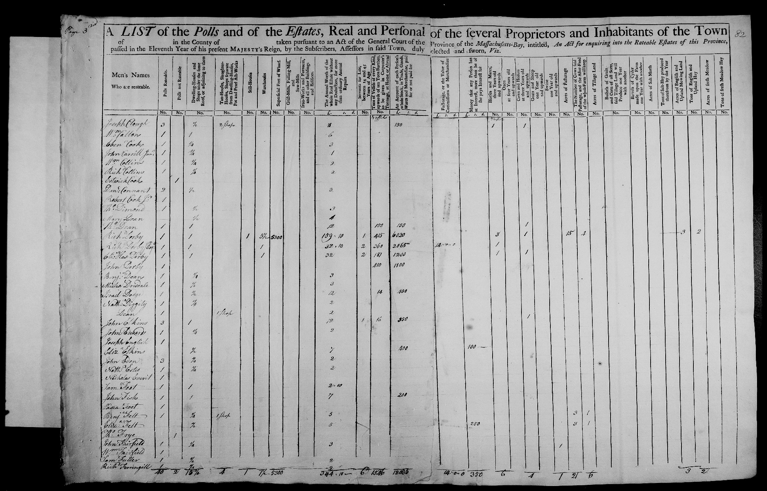

1771 Tax Inventory

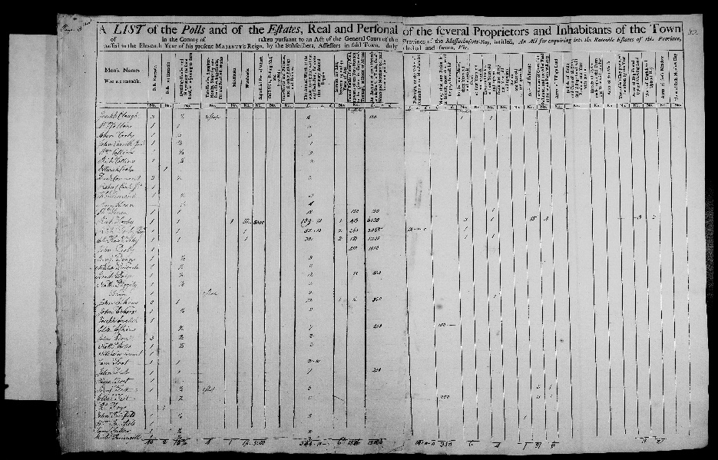

Citation and Credit:

Massachusetts State Archives collection, colonial period, 1622-1788; v. 134 -- Valuation of Towns, 1771.

Transcription

Servants for Life,
between 14 and 45
Years of Age

Richard Derby 1
Richard Derby, Junior, Esquire 2
Elias Hasket Derby 2

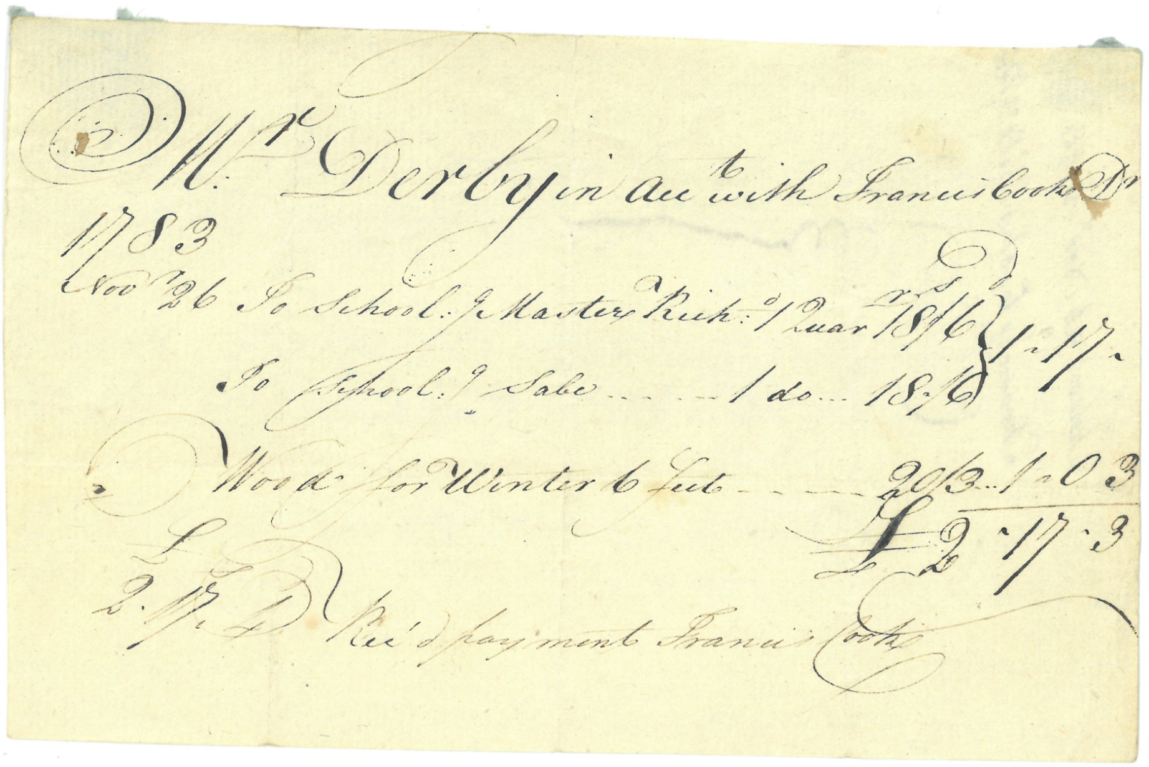

1783 Receipt

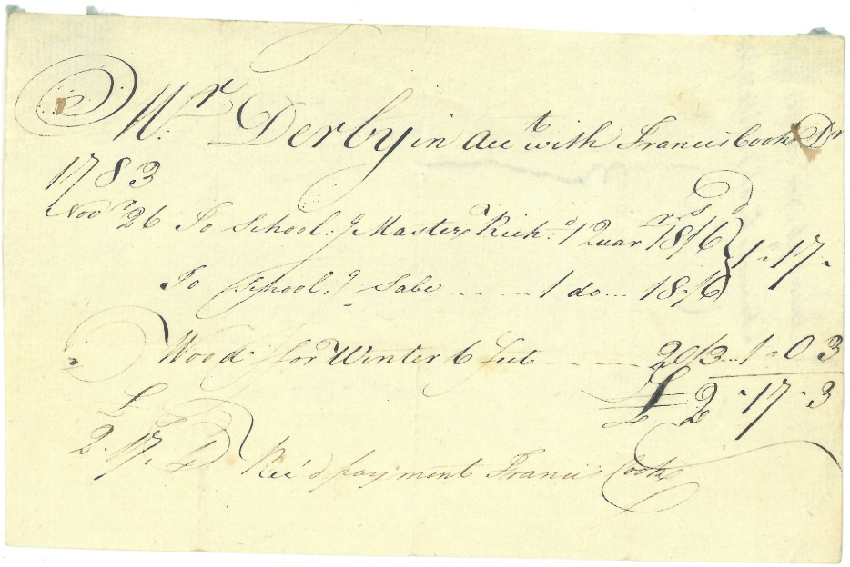

Citation and Credit:
Derby Family Papers, MSS 37, Box 17, Folder 1
Courtesy of The Phillips Library, Peabody Essex Museum, Salem, Mass.

Transcription

Mr. Derby in account with Francis Cook
1783
Nov. 26 To schooling Master Richard . . 1 Quarter
To schooling Sabe . . . . . . . . . . . 1 ditto
Wood for Winter 6 feet . . . . . .
£
2.17.3 Received payment Francis Cook

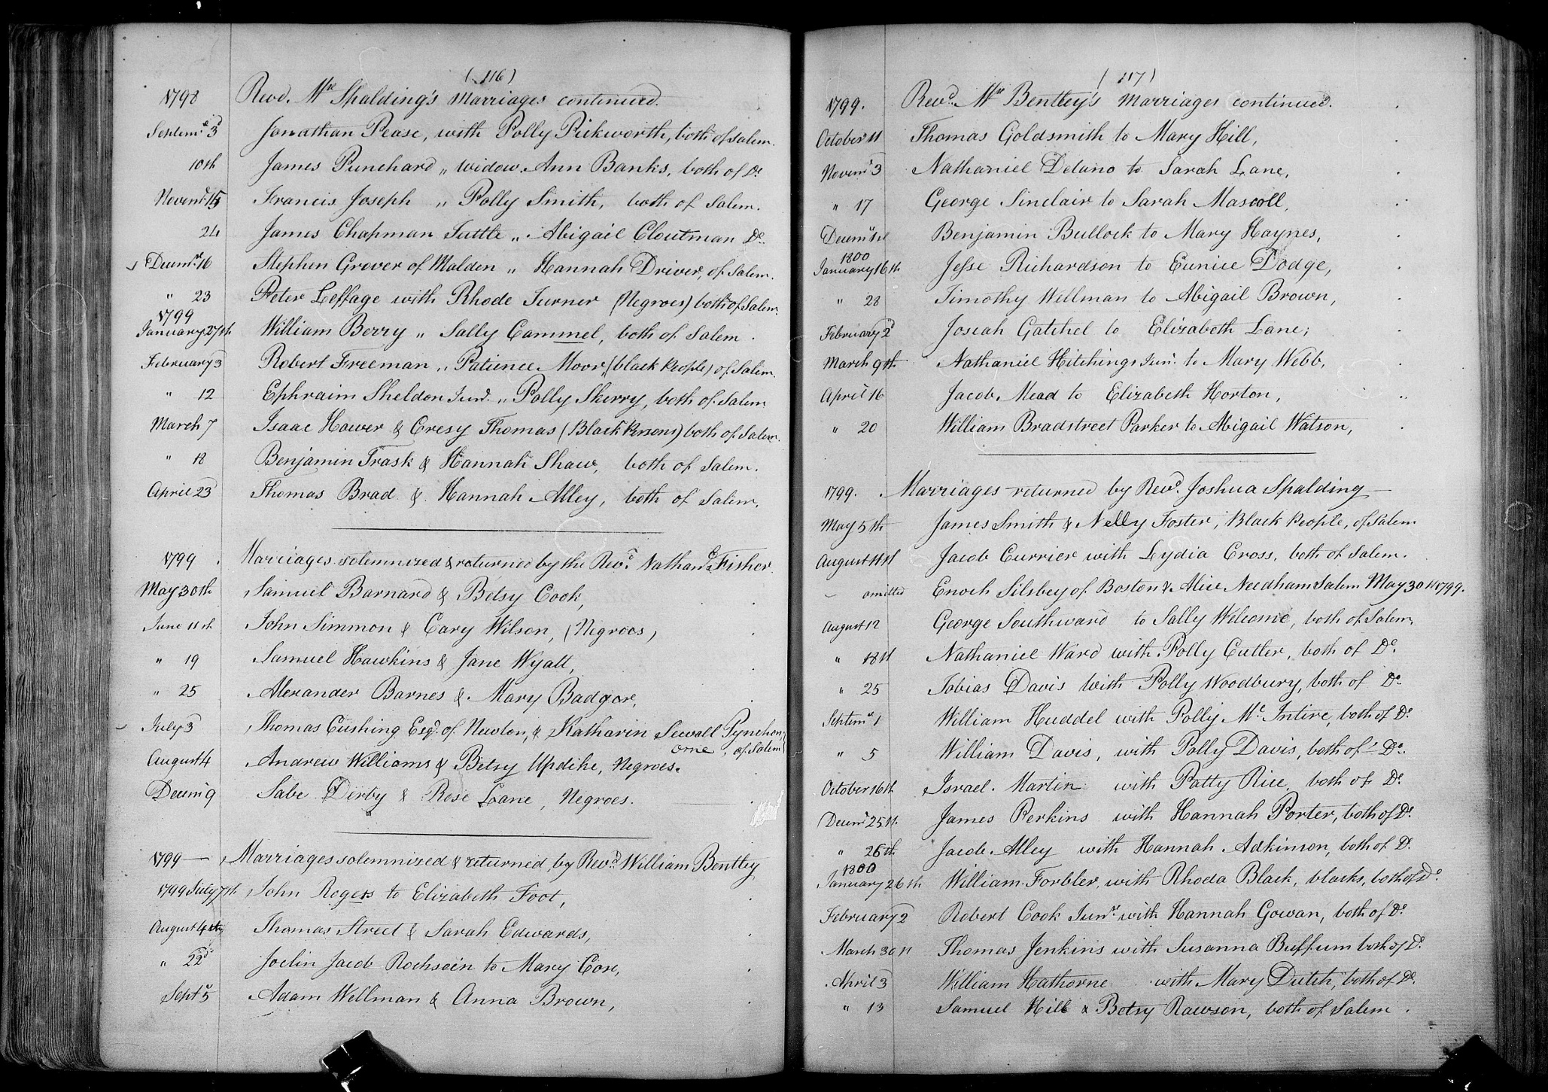

1799 Marriage Record

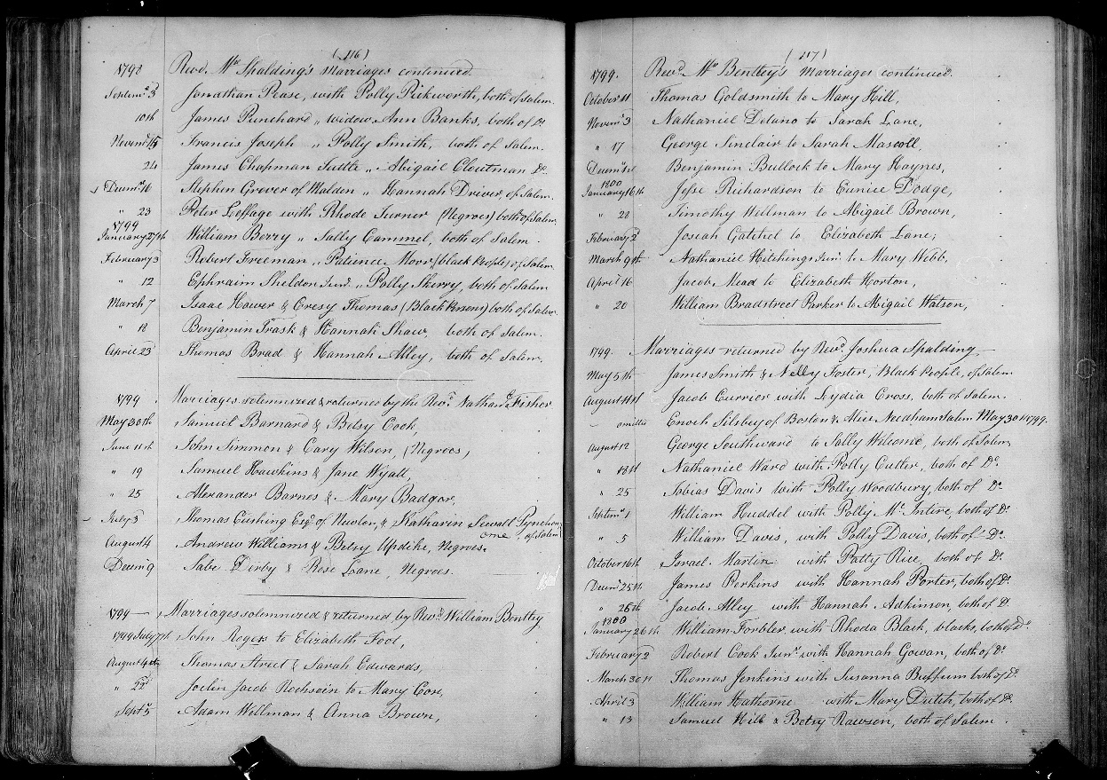

Citation and Credit:
“Massachusetts, Town Clerk, Vital and Town Records, 1626-2001," database with images, FamilySearch, Essex > Salem > Marriages 1695-1815 vol 4 > image 62 of 191; citing Massachusetts Secretary of the Commonwealth, Boston.

Transcription

December 9 Sabe Derby and Rose Lane, [People of Color]

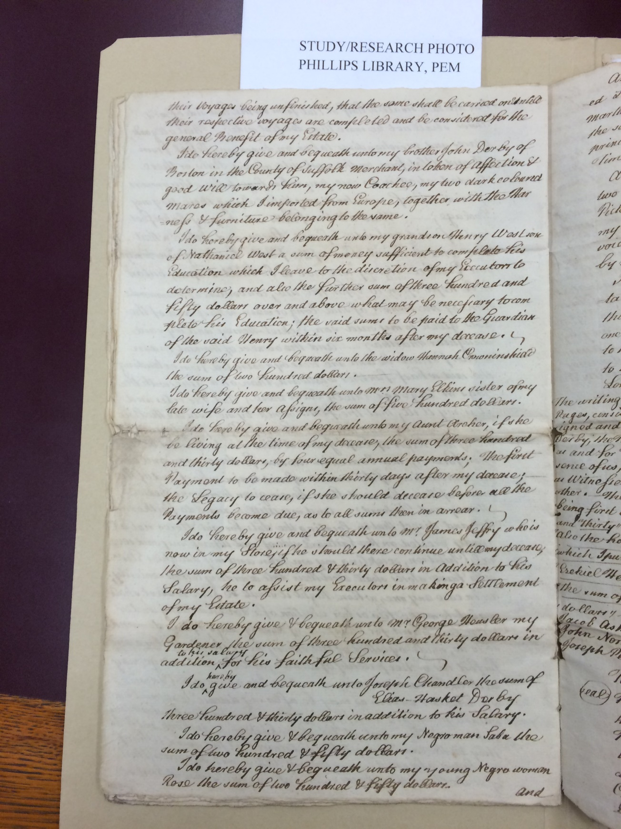

1799 Will, page 1

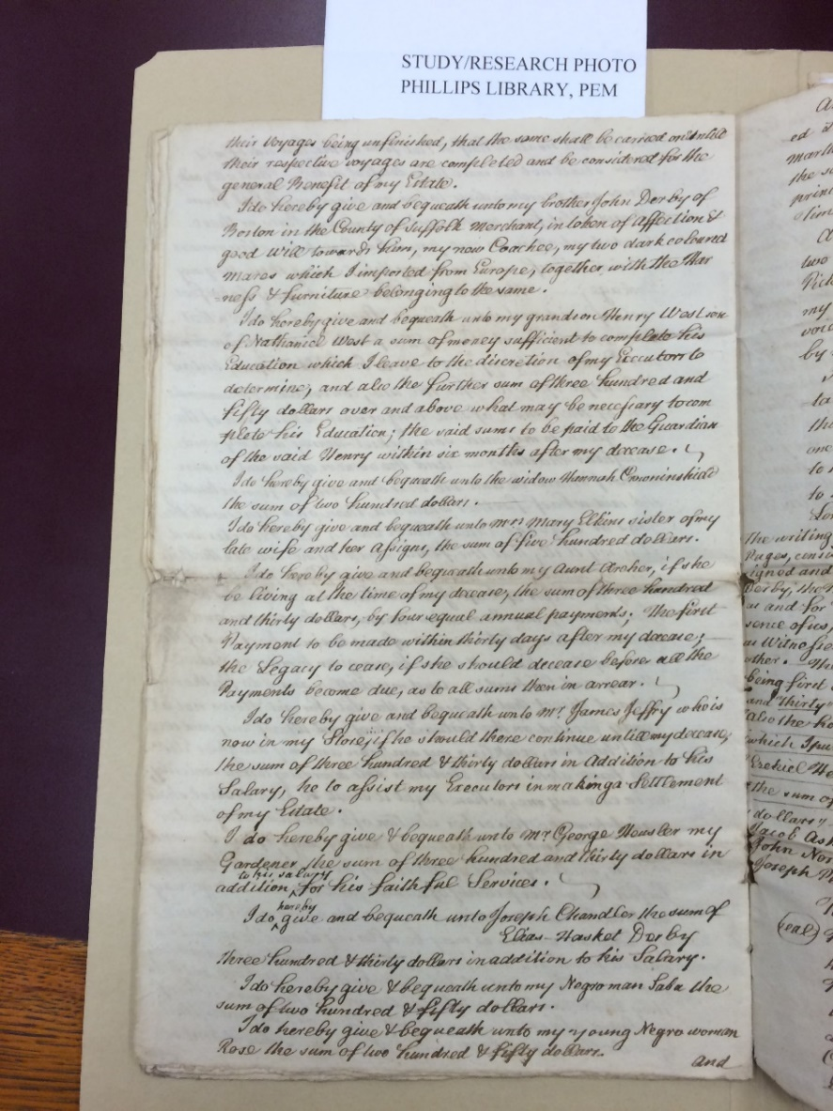
Citation and Credit:
Derby Family Papers, MSS 37, Box 19, Folder 1
The Phillips Library, Peabody Essex Museum, Salem, Mass.

Transcription

I do hereby give & bequeath unto my Negro man Saba the
sum of two hundred & fifty dollars.
I do hereby give & bequeath unto my young Negro woman
Rose the sum of two hundred & fifty dollars.

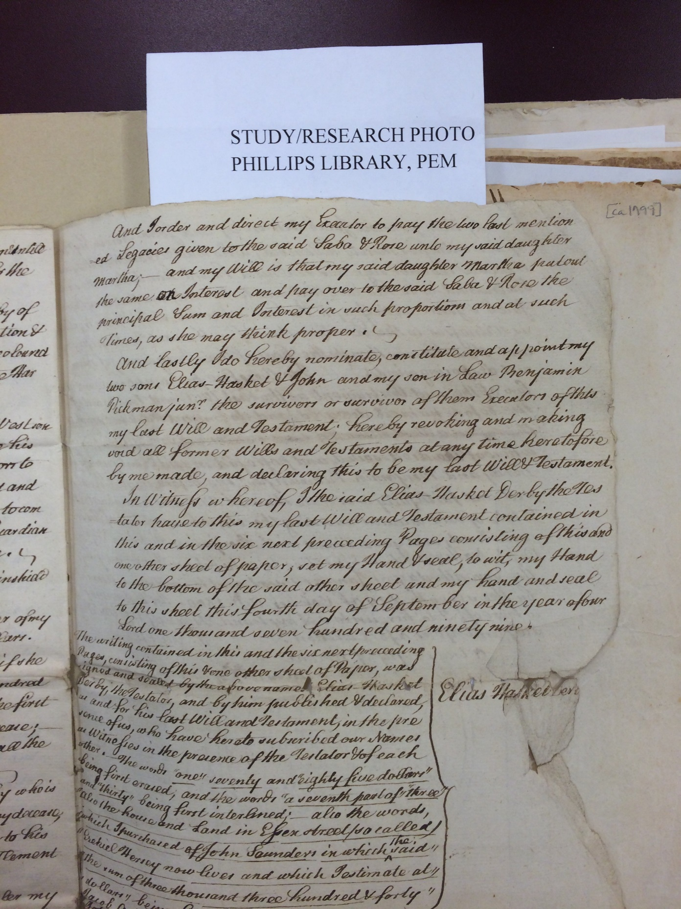

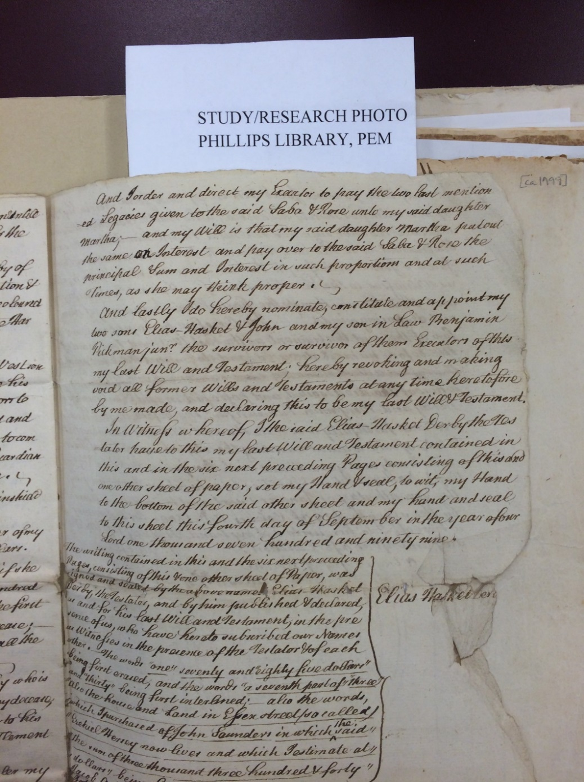
1799 Will, page 2

Citation and Credit:
Derby Family Papers, MSS 37, Box 19, Folder 1
The Phillips Library, Peabody Essex Museum, Salem, Mass.

Transcription

And I order and direct my executor to pay the two last mentioned legacies given to the said Sabe & Rose unto my said daughter Martha. . .
and my will is that my said daughter Martha putout
the same on interest and pay over to the said Saba & Rose the
principal sum and interest in such proportions and at such
times, as she may think proper.

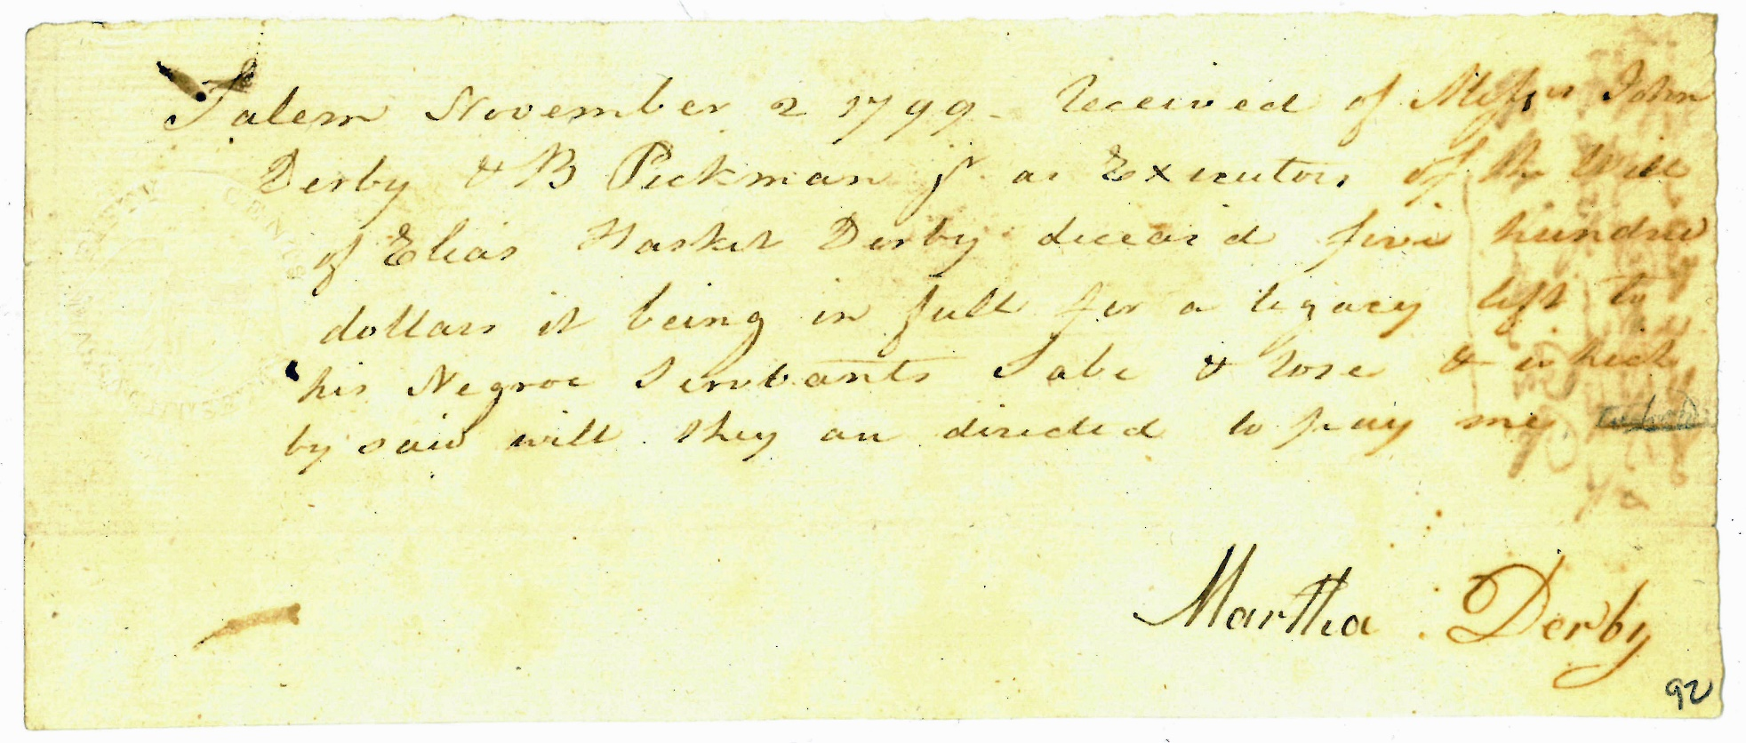

1799 Receipt

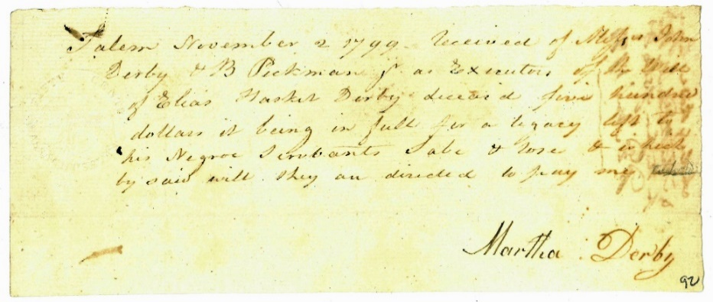

Citation and Credit:
Derby Family Papers, MSS 37, Box 19, Folder 1, Phillips Library, Peabody Essex Museum, Salem, Mass.

Transcription

Salem November 2, 1799. Received of Misters John
Derby & B Pickman, Jr. as executors of the will
of Elias Hasket Derby deceased five hundred
dollars is being in full for a legacy gifts
to his Black servants Sabe 7 Rose & in which
by said will they are directed to pay me.

Martha Derby

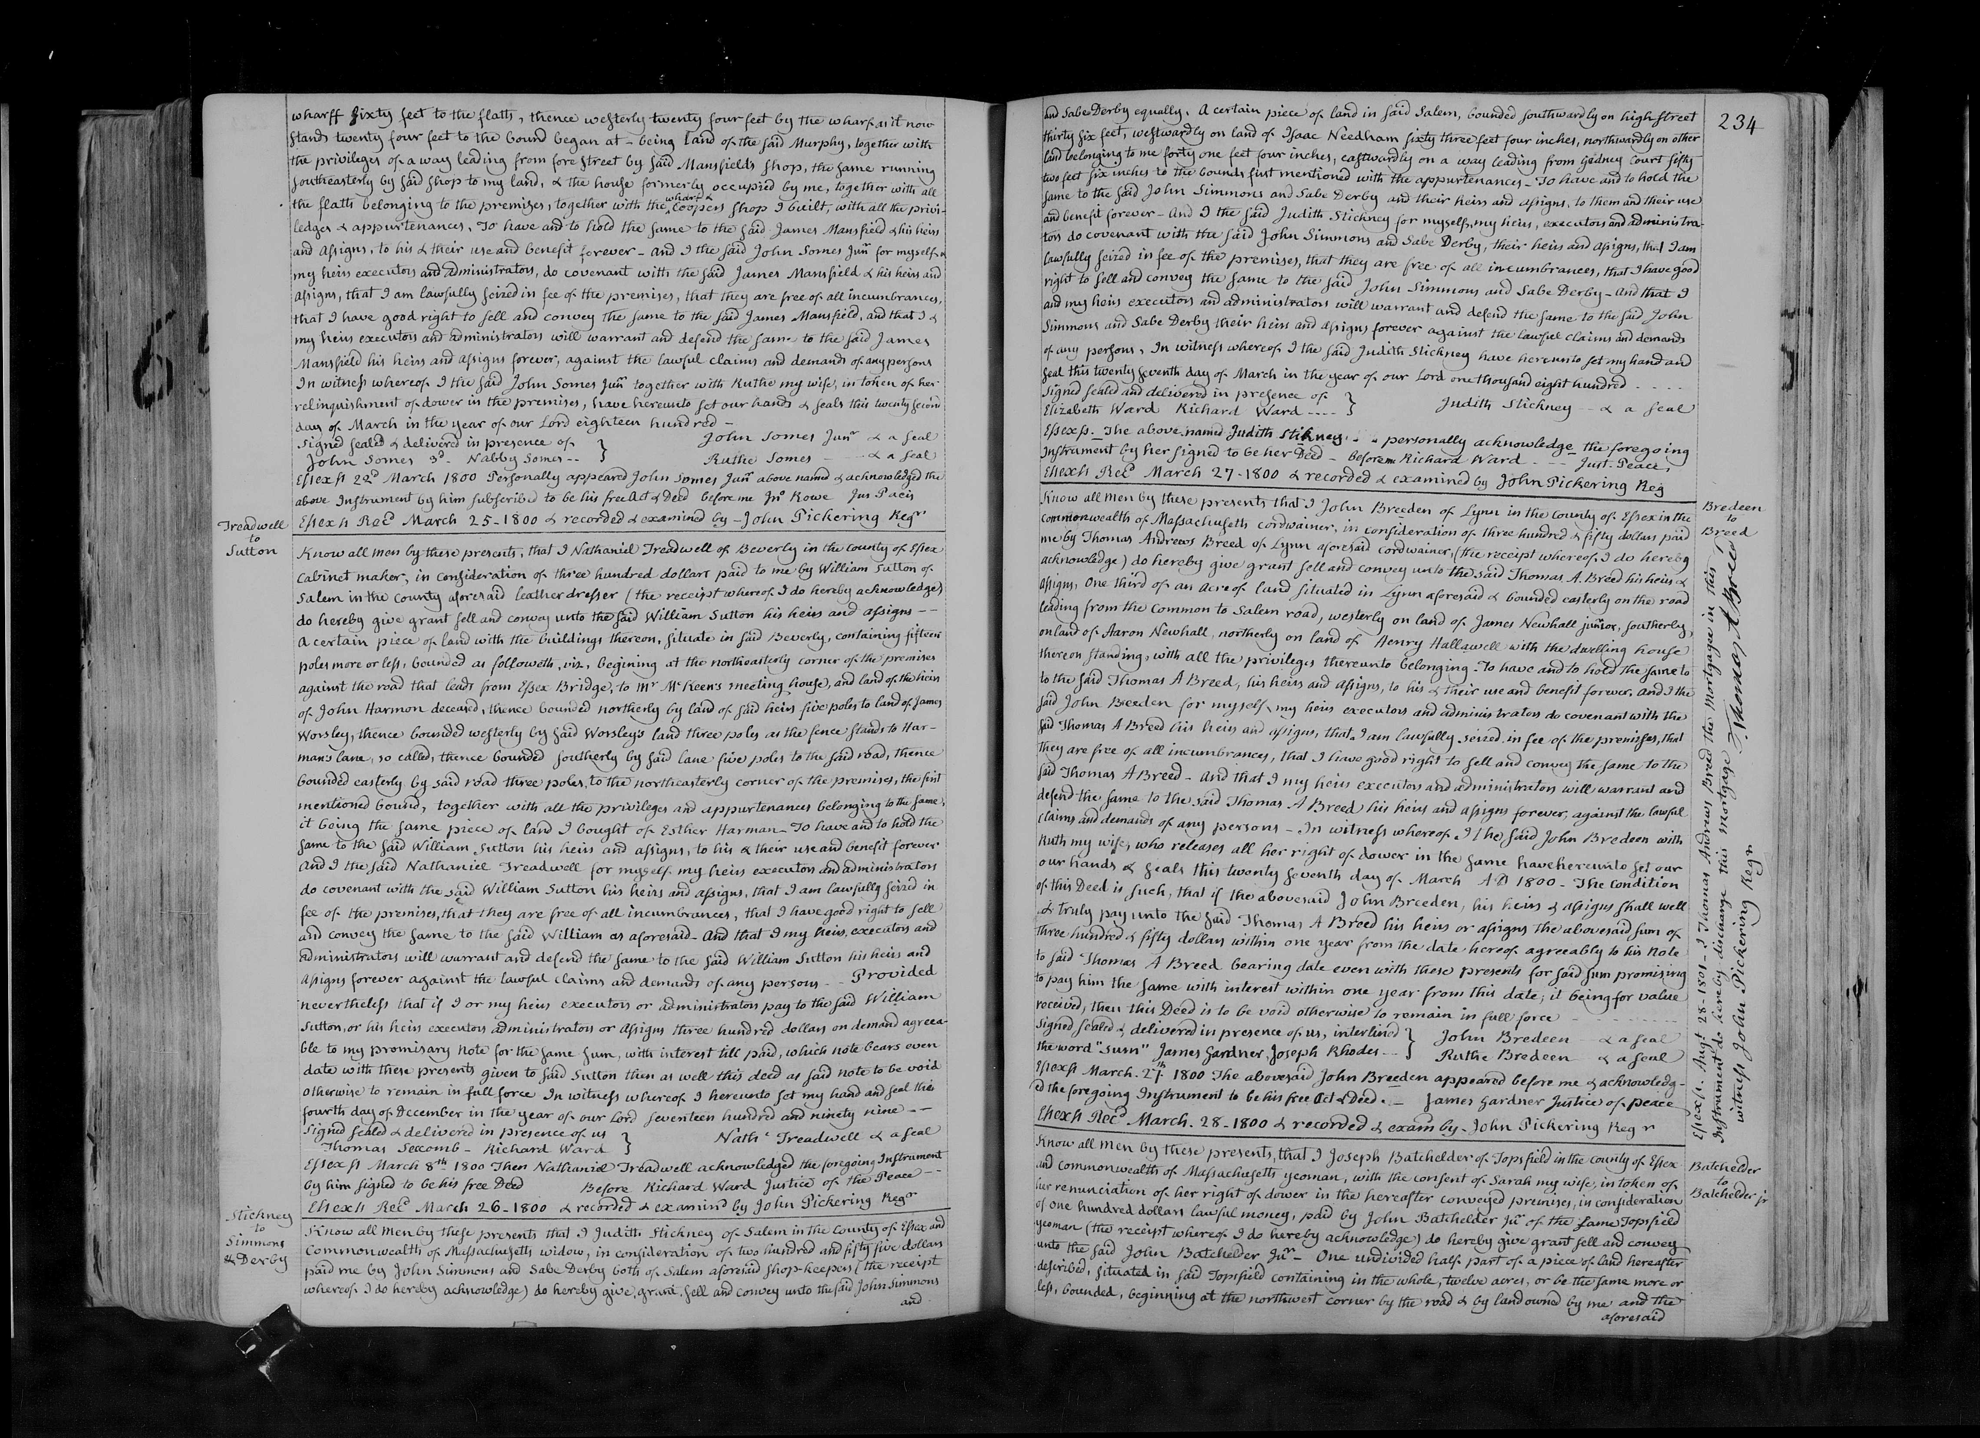
1800 Land Sale

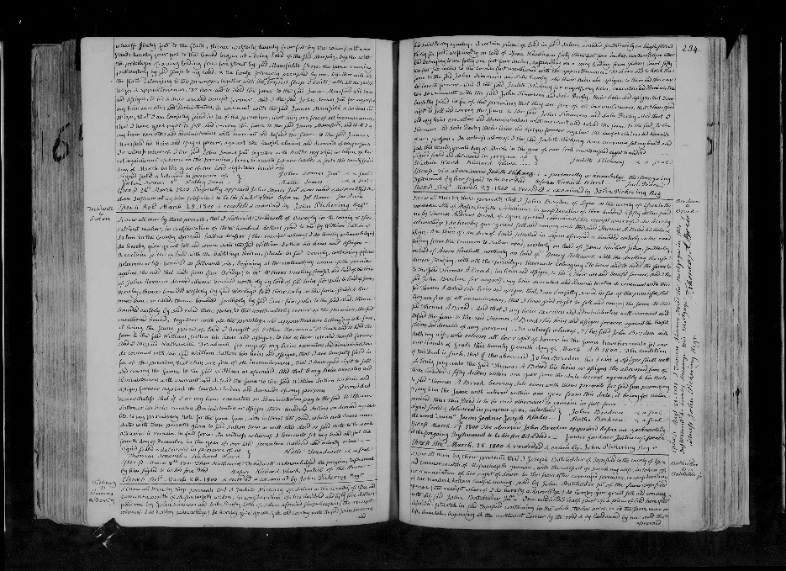

Citation and Credit:
"Massachusetts Land Records, 1620-1986," images, FamilySearch, Essex > Deeds 1797-1800 vol 164-165 > image 534 of 619; county courthouses and offices, Massachusetts.

Transcription

Know all men by these presents that I Judith Stickney of Salem in the County of Essex and Commonwealth of Massachusetts widow, in consideration of $255 dollars paid me by John Simmons and Sabe Derby both of Salem aforesaid shopkeepers (the receipt whereof I do hereby acknowledge) do hereby give, grant, sell and convey unto the said John Simmons and Sabe Derby equally.
A certain piece of land in said Salem, bounded southwardly on high street 36 feet, westwardly on land of Isaac Needham 63 feet 4 inches, northwardly on other land belonging to me 41 feet 4 inches, eastwardly on a way leading from Gedney Court 52 feet 6 inches to the bounds first mentioned with the appurtenances.
To have and to hold the same to the said John Simmons and Sabe Derby and their heirs and assigns, to them and their use and benefit forever. And I the said Judith Stickney for myself, my heirs, executors, and administrators do covenant with the said John Simmons and Sabe Derby, their heirs and assigns, that I am lawfully seized in fee of the premises, that they are free of all incumbrances, that I have good right to sell and convey the same to the said John Simmons and Sabe Derby.
And that I and my heirs, executors, and administrators will warrant and defend the same to the said John Simmons and Sabe Derby their heirs and assigns forever against the lawful claims and demands of any persons, in witness thereof, I the said Judith Stickney have hereunto set my hand and seal this 27th day of March in the year 1800.

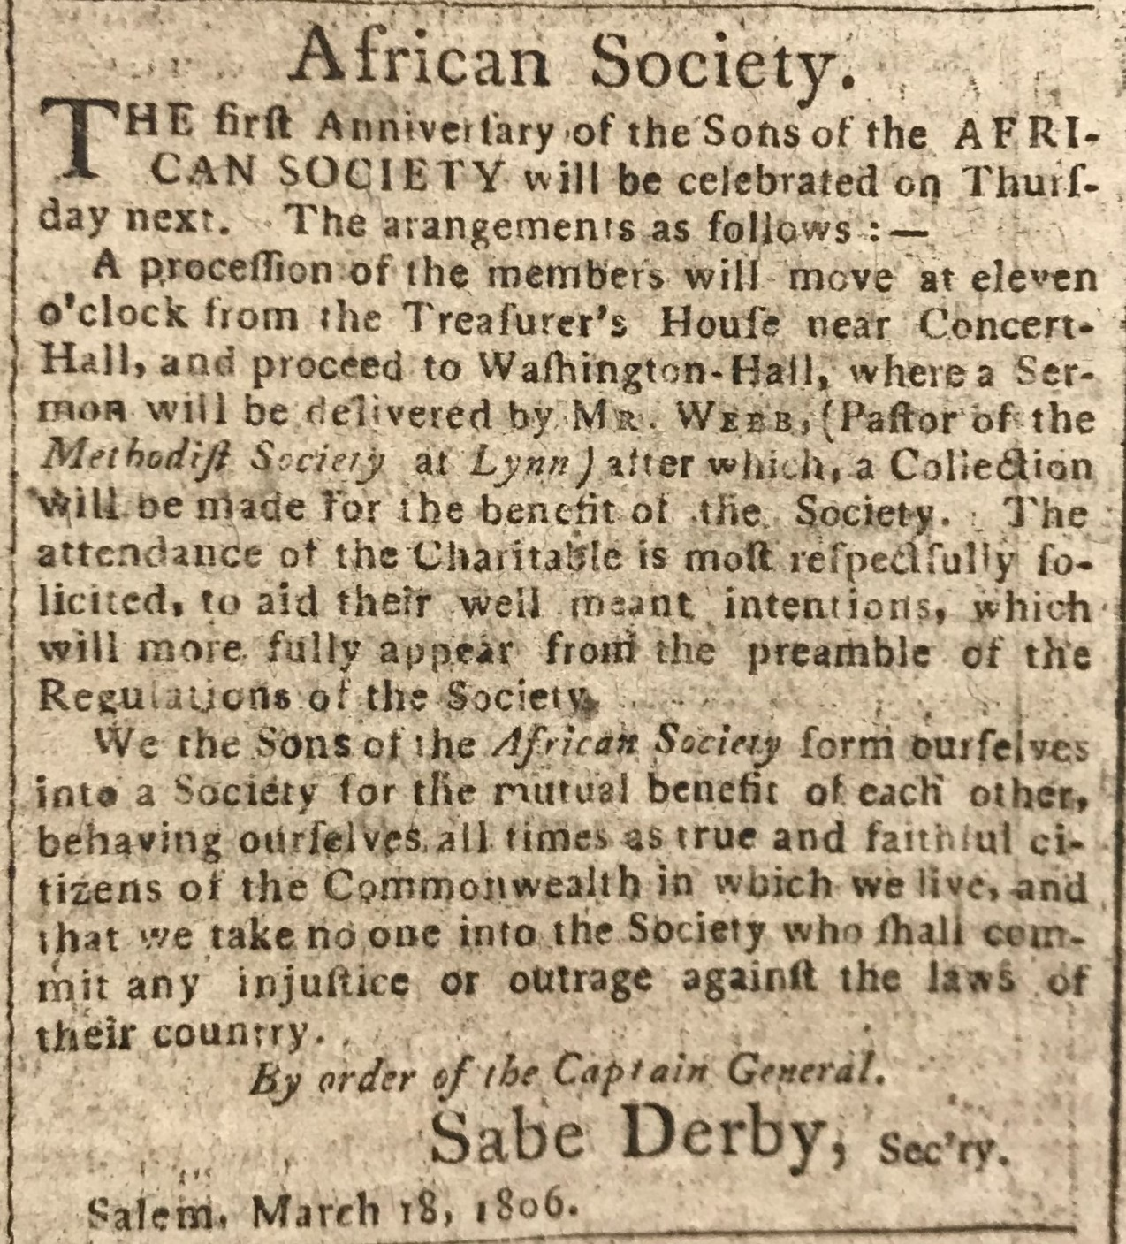

1806 Newspaper Ad

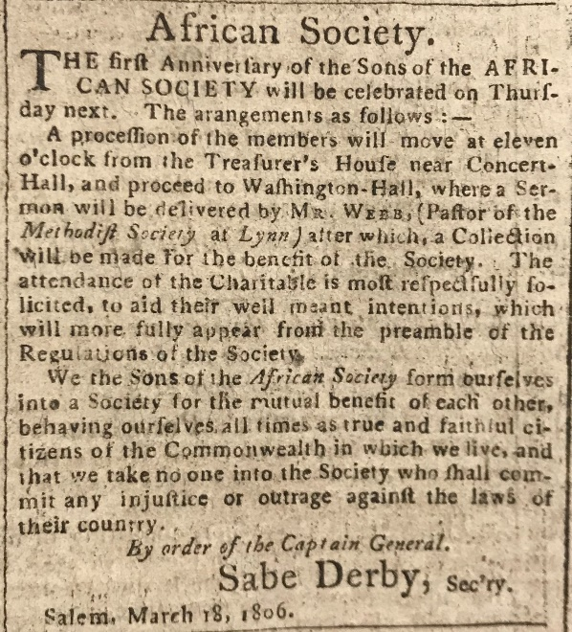

Citation and Credit:
Salem Gazette, March 18, 1806
Museum of Printing, Haverhill, Mass.

Transcription

African Society.
The first Anniversary of the Sons of the African Society will be celebrated on Thursday next. The arrangements as follows:--
A procession of the negroes will move at eleven o’clock from the Treasurer’s House near Concert Hall, and proceed to Washington Hall, where a Sermon will be delivered by Mr. Webb, (Pastor of the Methodist Society at Lynn) after which, a Collection will be made for the benefit of the Society. The attendance of the Charitable is most respectfully solicited, to aid their well meant intentions, which will more fully appear from the preamble of the Regulations at the Society.
We the Sons of the African Society form ourselves into a Society for the mutual benefit of each other behaving ourselves all times as true and faithful citizens of the Commonwealth in which we live, and that we take no one into the Society who shall commit any injustice or outrage against the love of their country.
By order of the Captain General,
Sabe Derby, Secretary.
Salem, March 18, 1806

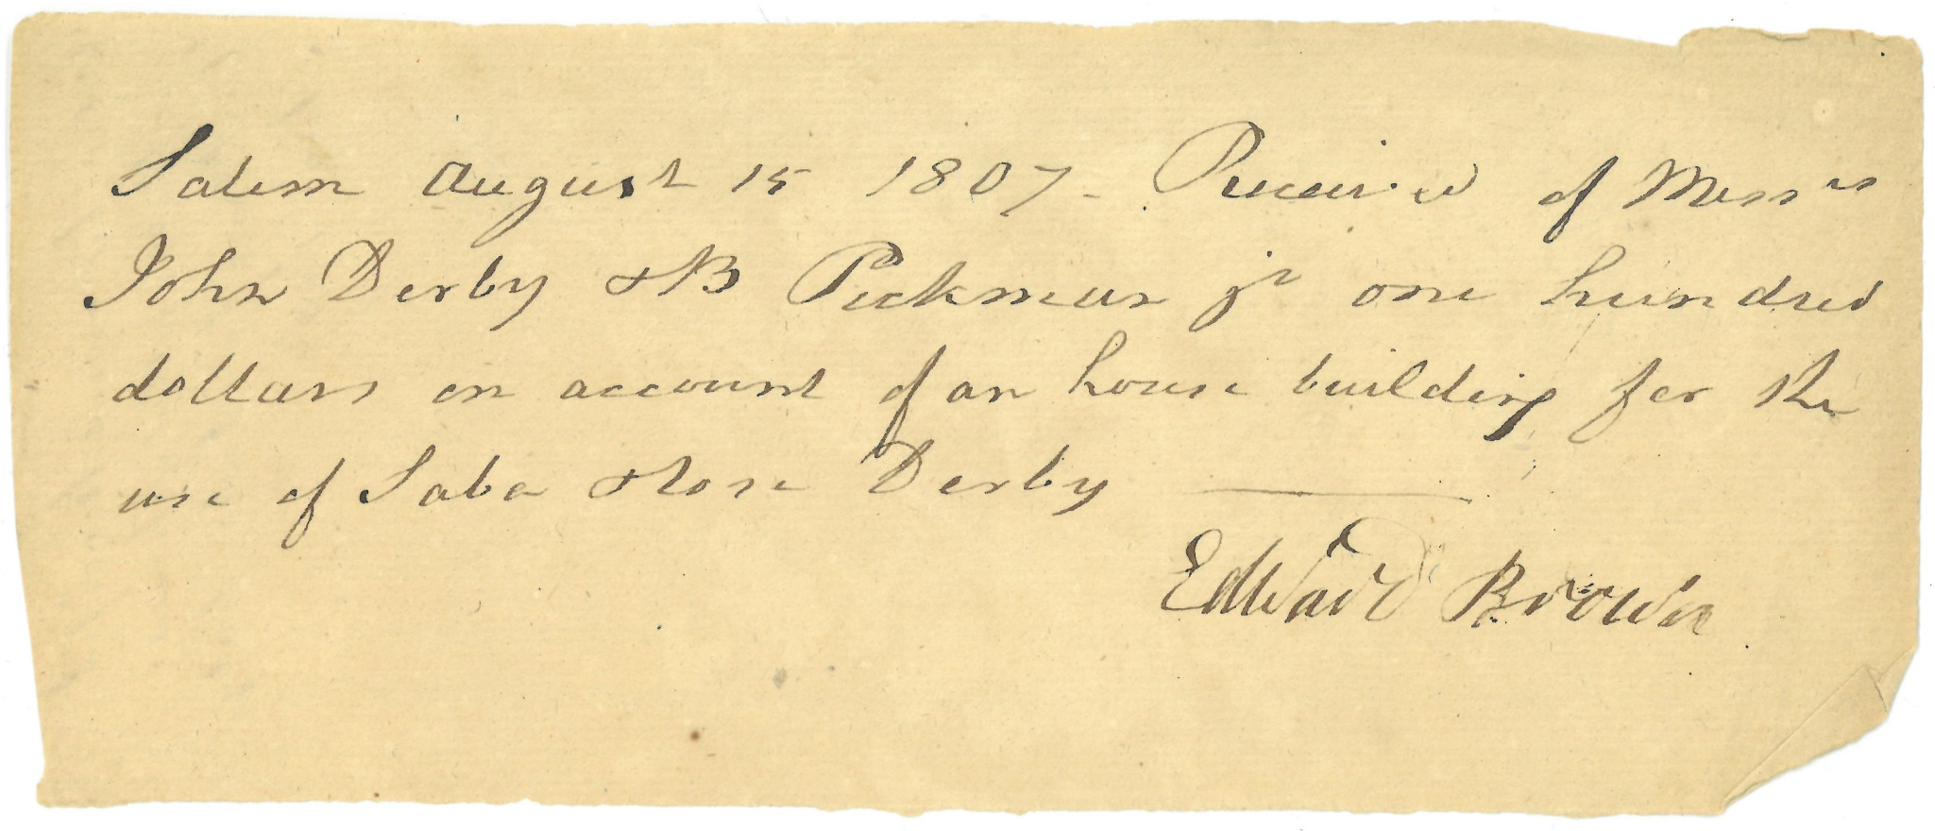

1807 Receipt

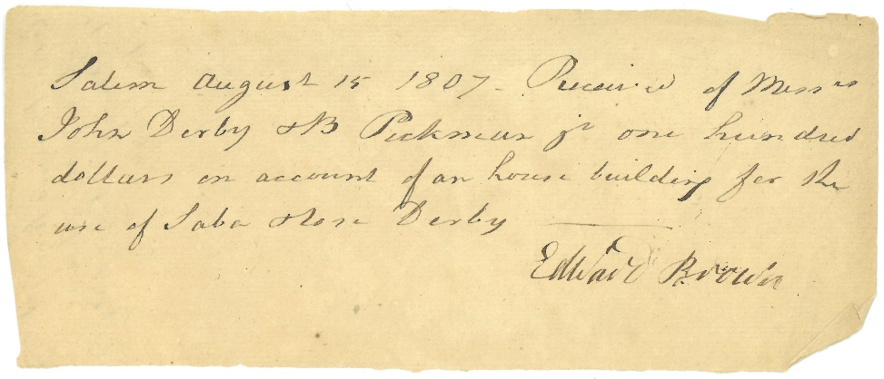

Citation and Credit:
Derby Family Papers, MSS 37, Box 19, Folder 2
The Phillips Library, Peabody Essex Museum, Salem, Mass.

Transcription

Salem August 15, 1807. Received of Misters
John Derby + B. Pickman, Jr one hundred
dollars on account of a house building for the
use of Saba + Rose Derby.
Edward Brown

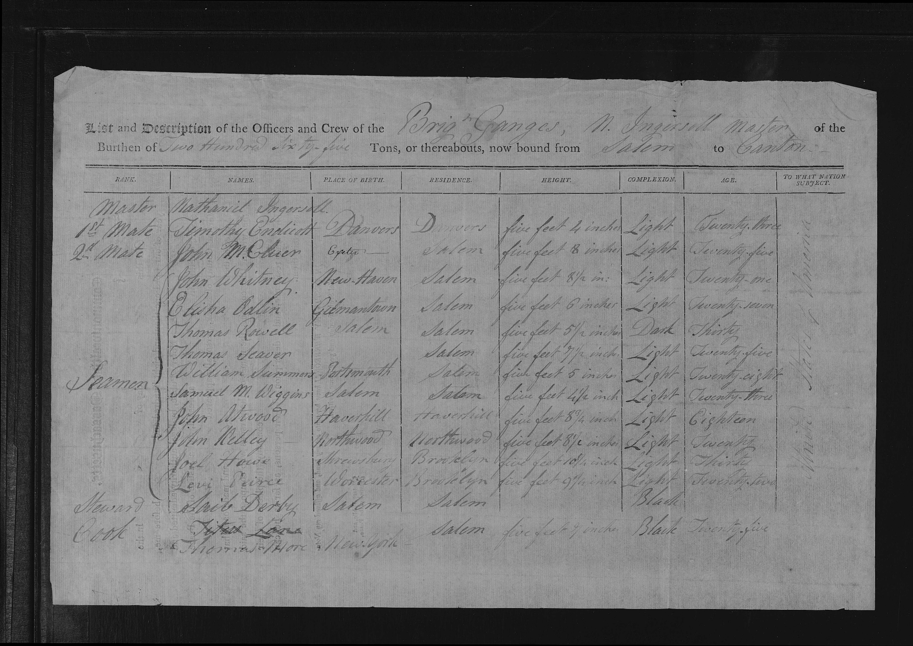

1809 Crew List

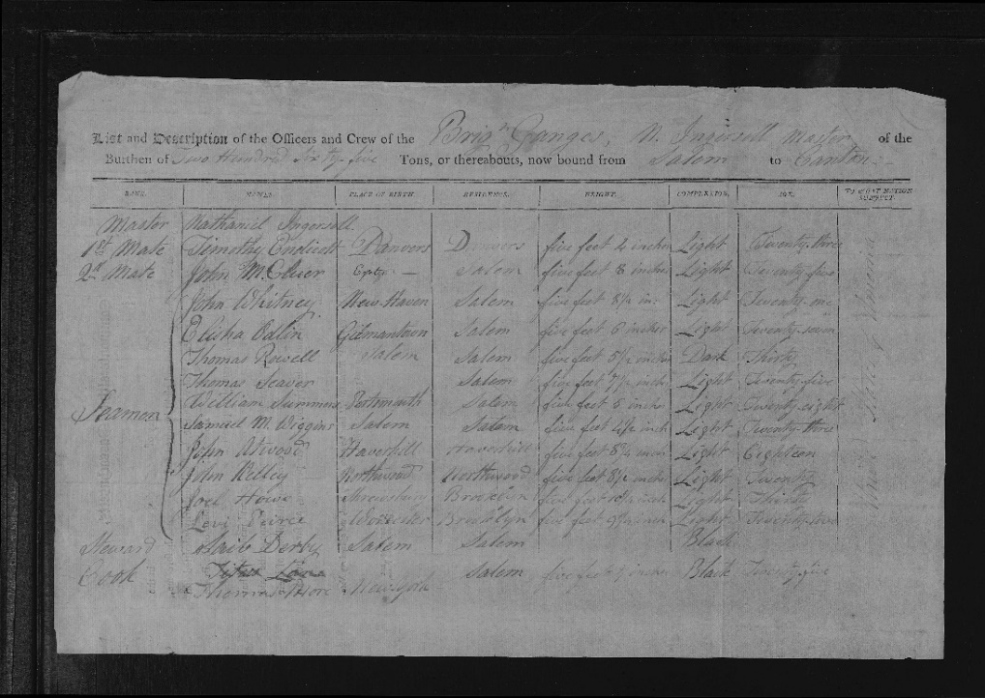

Citation and Credit:
"Massachusetts, Salem and Beverly Crew Lists and Shipping Articles, 1797-1934," database with images, Crew lists > 1807-1809 > image 477 of 597; citing NARA NAID 1600758, 1600870, and 1600759, National Archives and Records Administration, Washington, D.C.

Transcription

List and Description of the Officers and Crew of the Brig Ganges, N. Ingersoll Master of the Burthen of Two Hundred Sixty-five tons, or thereabouts now bound from Salem to Canton.

Rank: Steward
Name: Saib Derby
Place of Birth: Salem
Residence: Salem
Height: left blank
Complexion: Black
Age: left blank
To What Nation Belong: United States of America

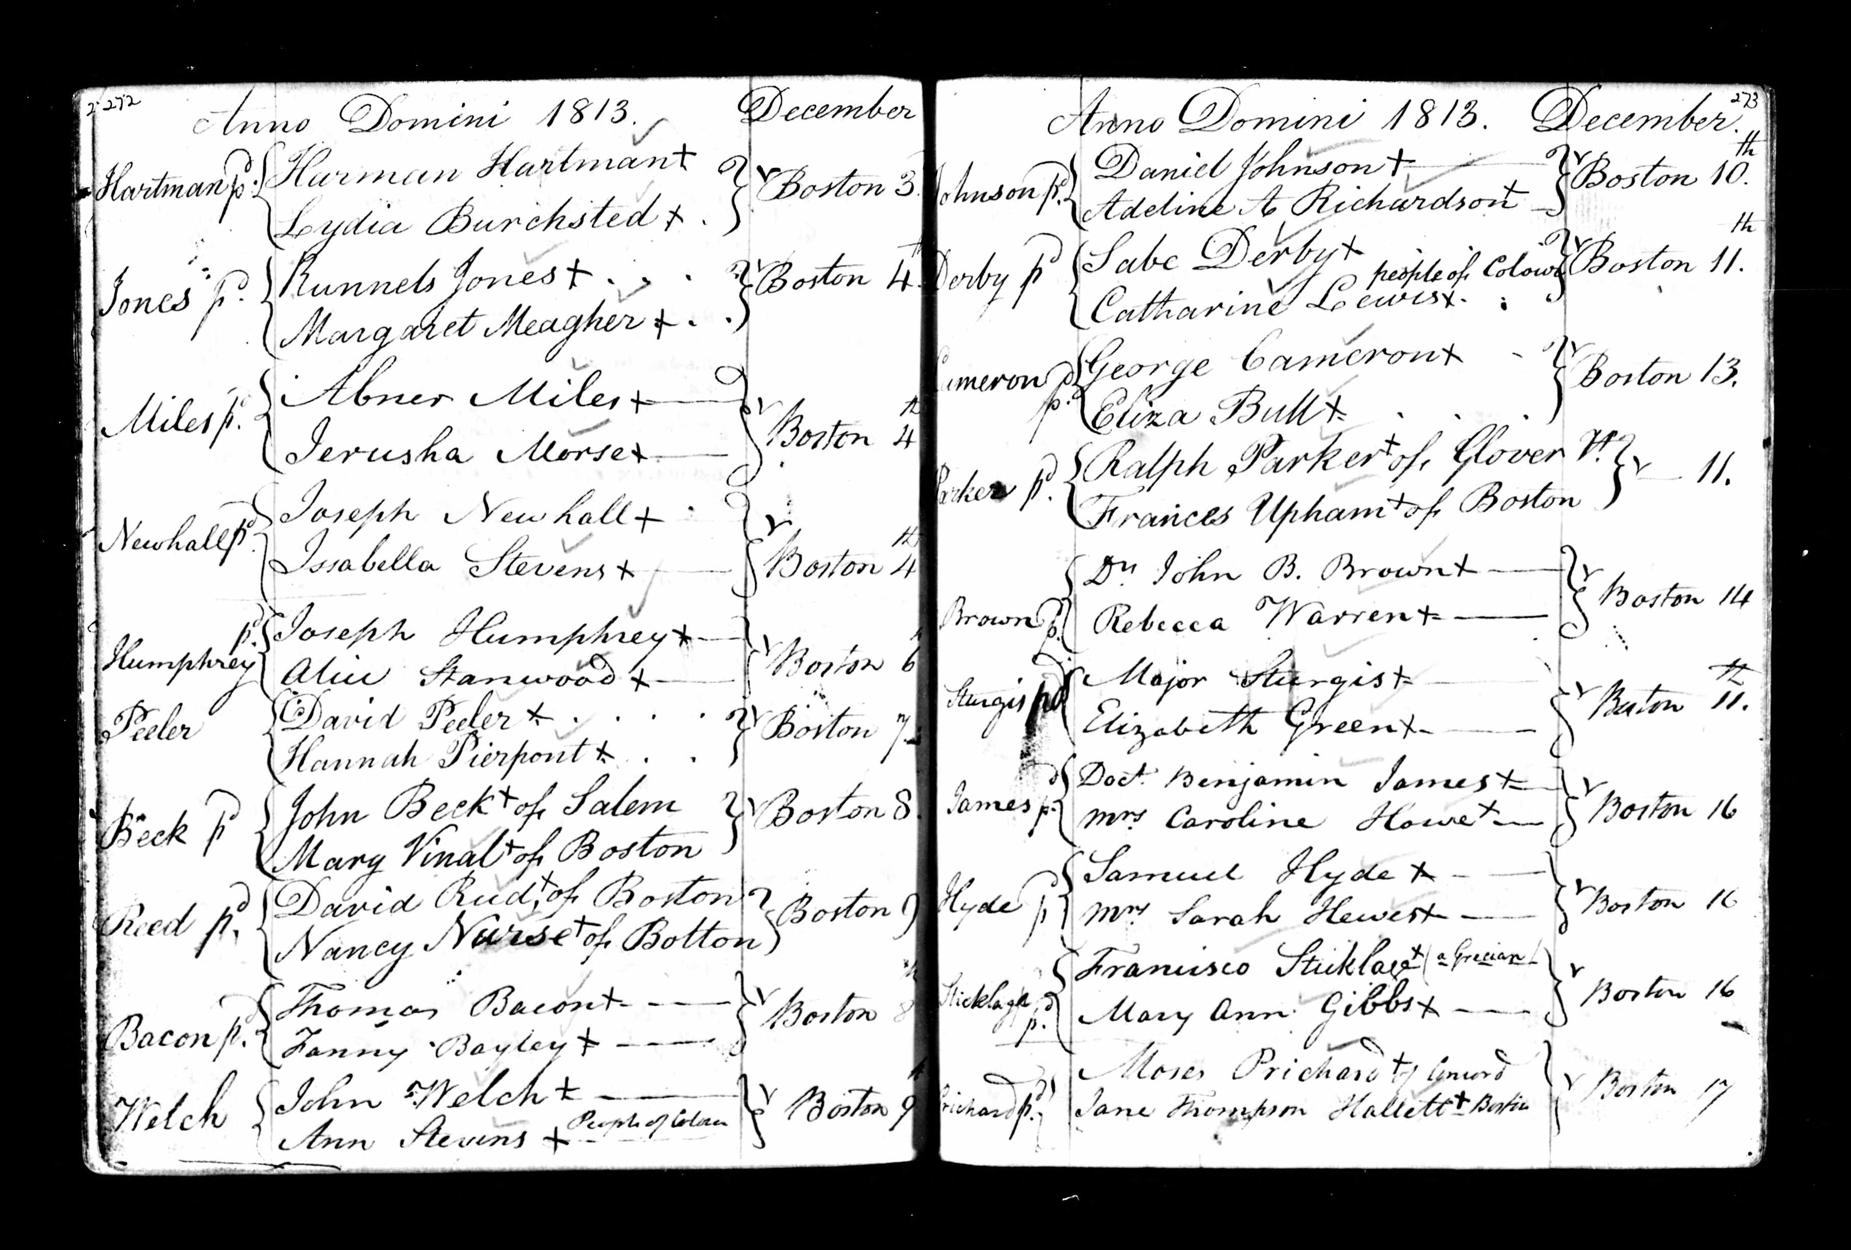

1813 Marriage Record

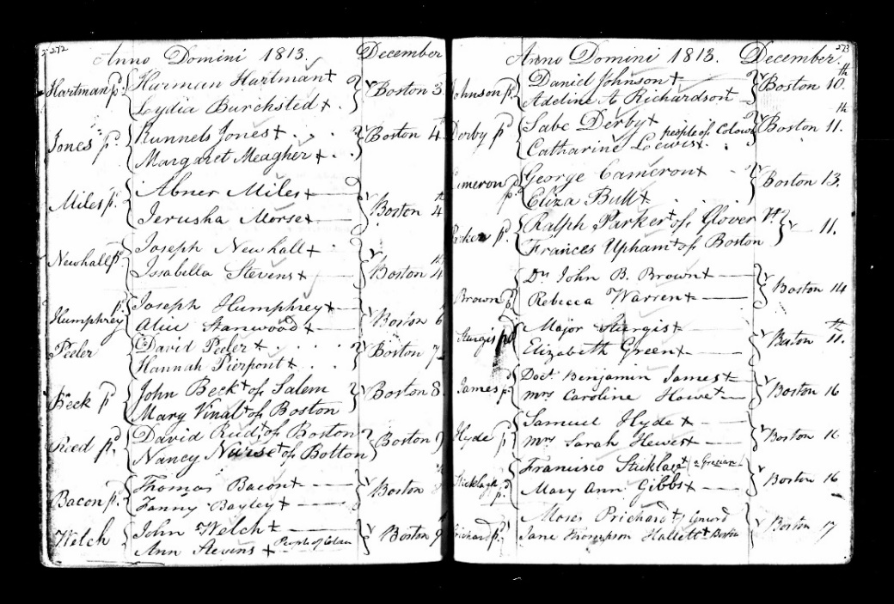

Citation and Credit:
“Boston Marriage Publications, 1807-1817; Vol· 8,” Ancestry.com. Massachusetts, U.S., Town and Vital Records, 1620-1988 [database on-line]. Provo, UT, USA: Ancestry.com Operations, Inc., 2011.

Transcription

Sabe Derby
Derby People of Color Boston Dec. 11th
Catharine Lewis

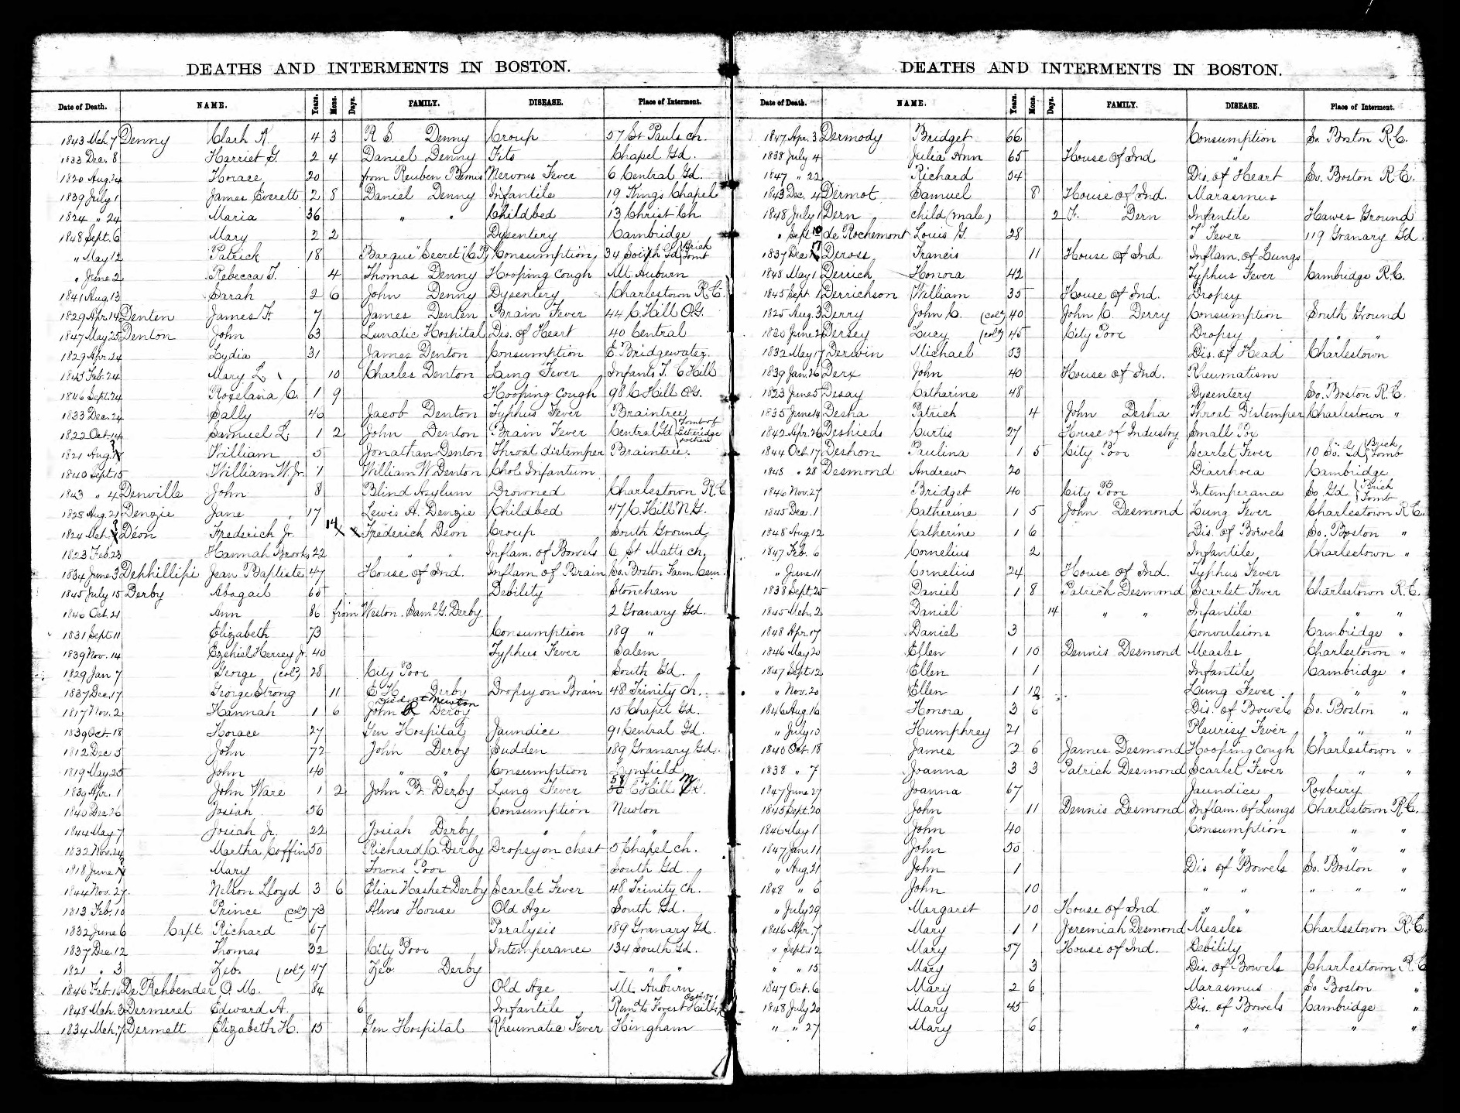

1821 Death Record

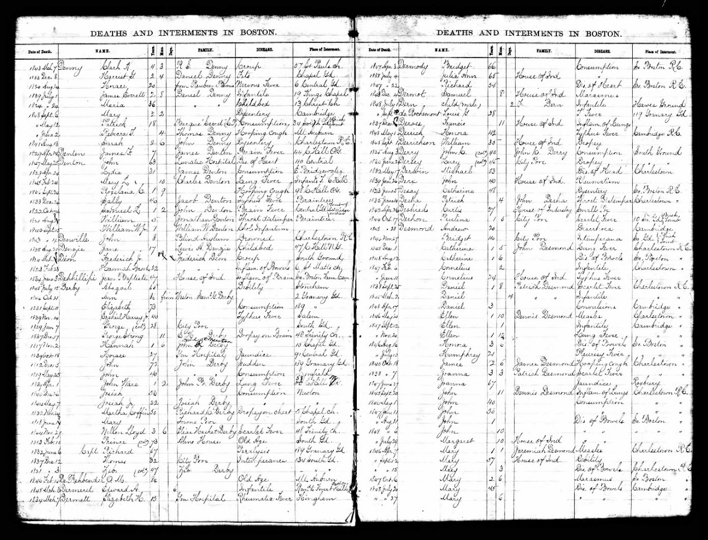

Citation and Credit:
“Births, Marriages and Deaths,” Ancestry.com. Massachusetts, U.S., Town and Vital Records, 1620-1988 [database on-line]. Provo, UT, USA: Ancestry.com Operations, Inc., 2011.

Transcription

Deaths and Internments in Boston

Date: Dec 3
Name: Zeb [Black]
Years: 47
Months: left blank
Days: left blank
Family: Zeb Derby
Disease: left blank
Place of Internment: South Burial Ground
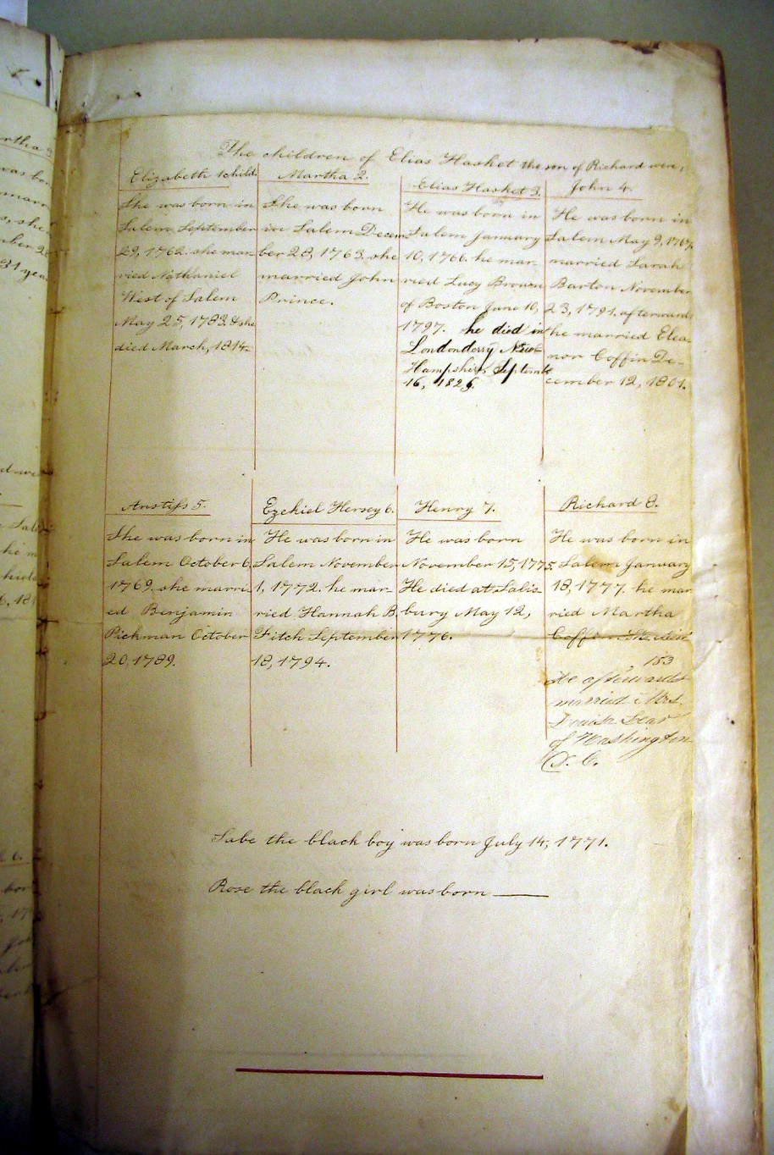

Undated Genealogy

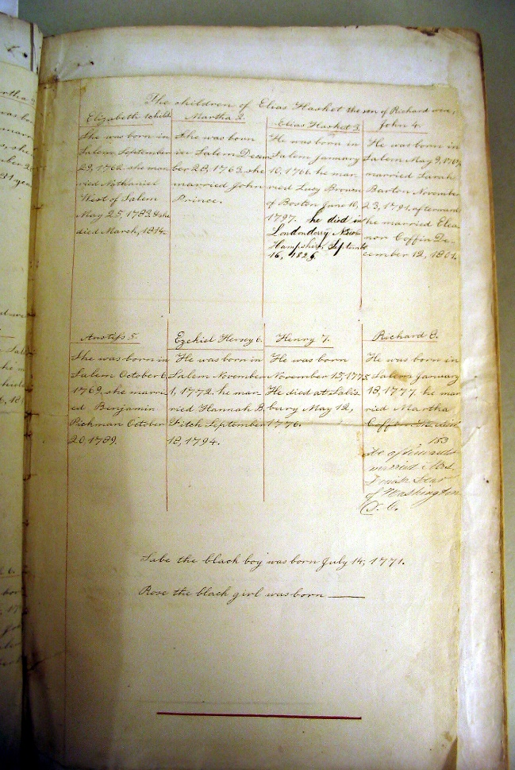

Citation and Credit:
Scan of the Derby family genealogy in the second volume of The Universal Bible or Every Christian Family’s Best Treasure, by S. Nelson. National Park Service Museum Collections, SAMA 3933.

Transcription

Sabe the black boy was born July 14, 1771

